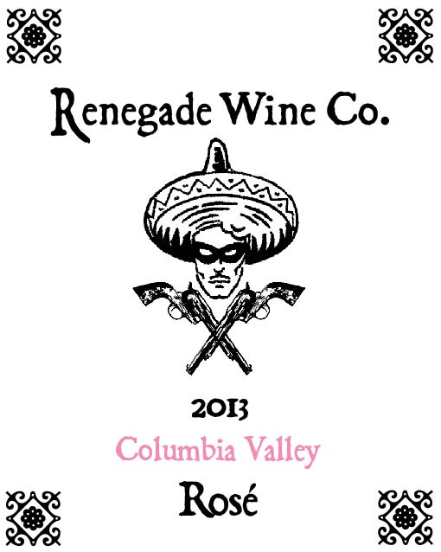

The Renegade Wine Co. is excited to release the newest vintage of our rose’, the 2013 Columbia Valley Rose’! It was made from 79% Syrah, 14% Cinsault, and 7% Counoise. The grapes were pressed directly after harvesting, and the juice was drained to stainless steel tanks, where the wine was fermented at a cool temperature to retain the fresh fruit characters of the final product. It has wonderful aromas of fresh pomegranates and citrus, some sweet red berries, and even rhubarb. This wine will be the perfect pairing with a fresh beet salad and crumbled goat cheese, or grilled salmon on your deck.

The 2012 version of this wine sold out in less than 5 weeks, and was named Seattle Metropolitan Magazines Rose’ of the Year. You will definitely want to stock up on this wine! The Renegade Wine Co. wines are brought to you by the amazing winemaking team at Sleight of Hand Cellars.

3.43 pH / .57 g/100mL TA / .48 g/100mL R.S / 12.5% Alc

